OSP2 (Open Source Peristaltic Pump)

Karim Lakra March 9th, 2018

Introduction
The core of this project is a 3D printed part, which is a peristaltic pump controlled Arduino.
The user can control the pump to :
- pump a liquid continuously
- the pump offers three type of programs:
  - fixed quantity: repeat a number of times pumping a fixed quantity and wait a defined time
    - example: repeat = 3 times, quantity = 6ml, interval = 9 sec
  - incremental quantity: repeat a number of times pumping an incremented quantity and wait a defined time
    - example: repeat = 6 times, starting quantity = 6ml, increment by = 3ml, interval = 9 sec ** This option is not yet complete, but I will update this instructable each time I made some advance.
  - and program from file: pump 18 different quantities, with a fixed interval between each quantity, the quantities can be random as: dose1 = 10ml, dose2 = 0.1ml...dose17 = 8ml, dose18 = 0ml

- the data this pump needs to work is stored to an SD card as a text files “.txt”, is easy to edit on your computer or by a tactile buttons via Arduino.
- the user can calibrate and configure the pump by entering a setting menu.
- the smallest quantity that can be pumped is 0.1ml
- about 200 ml/min can be pumped
- the direction can be changed
- a default speed and direction can be set and stored to the SD card for the continuous pumping so the user don’t need to press hundreds of times each time the pump is started.

The pump have 3 sections that offers different informations for the user:
- top section: the path, which is a text showing the navigation tree:
  - when you enter settings and speed is selected: settings>speed
- right section:
  - shows the state of the pump(run/pause)
  - direction: fill/empty
  - control: local/remote
- foot section: guides the user with different messages about actions needed, successful changes, selections, errors..etc

The history
I needed for many things a water pump(liquid pump), and I found the peristaltic pump the best for a precision dosing, can be used for continuous pumping, the liquid is separated by the tubing from other parts, it can be used for food and many applications safely, offers easy maintenance… You can read more about them if you need just google it!
After I watched many designs, as always, I like to design my own to see how far I can go, so feel free to suggest any useful tips!
I started last year the project from a user interface using Arduino Mega 2560 with a TFT display, but I left this project for some time .
This year 2018 I spent some time writing and testing the pump and code together when I finished the graphical interface. After many hours testing and optimizing the code, I got the pump running as needed.

The coding is not professional, but a dirty quick working solution. I used my knowledge from other coding languages(please suggest any code optimization if needed)
By the way, I thank all people who shared their libraries and examples and helped directly or indirectly in this project, I removed their comments and credit, just to keep a clean code as possible, otherwise it will be a long header. I will mention names in the end of this instructable, if you recognize your code here, but not your name, let me know if you want to be a part of this project, and that your name will be added to the list.

The capacity of this pump (I started the first tests with 120ml/min but moved to 200) is 200ml/min. This value can be pushed a little bit upper, but I didn't want to destroy the tubing(this quantity is fine for me and I think it is enough for many applications) it is already higher than the value given by the tubing manufacturer, which is 80ml/min.

Upcoming features
There is more features planed to be added to this pump to make it useful for many applications as:
- remote control: 4-20mA, by an input pulses, by HIGH/LOW states or other options(I didn’t decided yet which one or maybe all of them).
- using a moisture sensor for plant watering.
- remote control and monitoring the pump via web application, for plant watering and other uses.
- adding a temperature sensor is an option, but low priority.

Why Arduino?
I was thinking to use a pic microcontroller with a 16x2 line display, to control the pump, but I changed my mind simply because:
- the pic microcontroller needs a separate programmer
- complicated in many ways compared to Arduino
- not easy for most of people
- Arduino is supported and the most used by a wide community
- make this pump open source not commercial
- there is a variety of ready to use modules for arduino
- using a TFT display shield with an SD card offers many possibilities to make a nice UI using ready free libraries.
- modules are ready and saves you lot of time of PCB designing and debugging.

Let’s start!

Parts needed for the 3D printed peristaltic pump

4 * M3 nuts
3 * M1,85x10 screw
3 * M3x3 screw
4 * M3x8 screw
4 * M3x11 screw
3 * Bearings 5x13x4mm 695ZZ(I attached also a printable bearing if you want to try it)
1 * Tubing PharMed BPT (information in the picture)

The files for 3D printing are also here:
https://www.thingiverse.com/thing:2819311

Print Settings (this settings works for me, but they are here just as a reference)
Printer: ANYCUBIC I3 MEGA
Material: ABS
Rafts: Doesn't Matter
Supports: Yes
Resolution: 0,4
Infill: 100%
Temperature: 240 °C
Bed temperature: 80 °C

The pump is easy to assemble, but bellow are a step by step pictures .

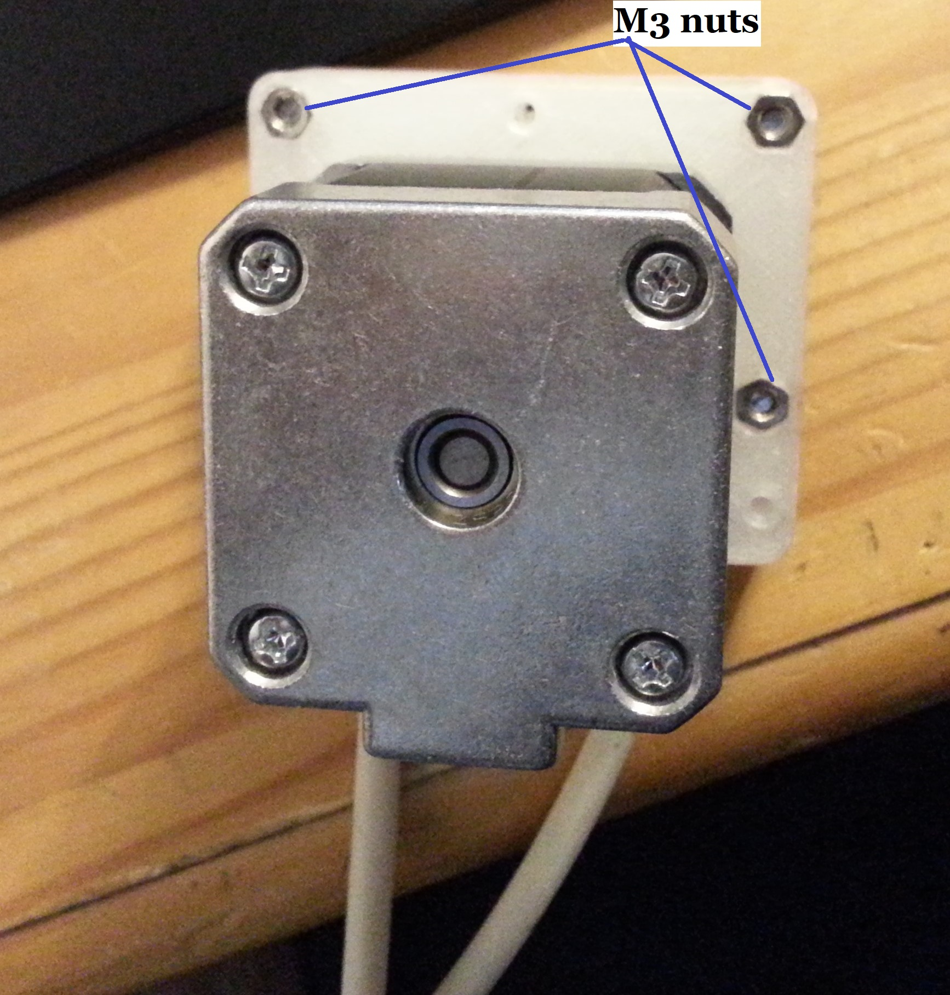
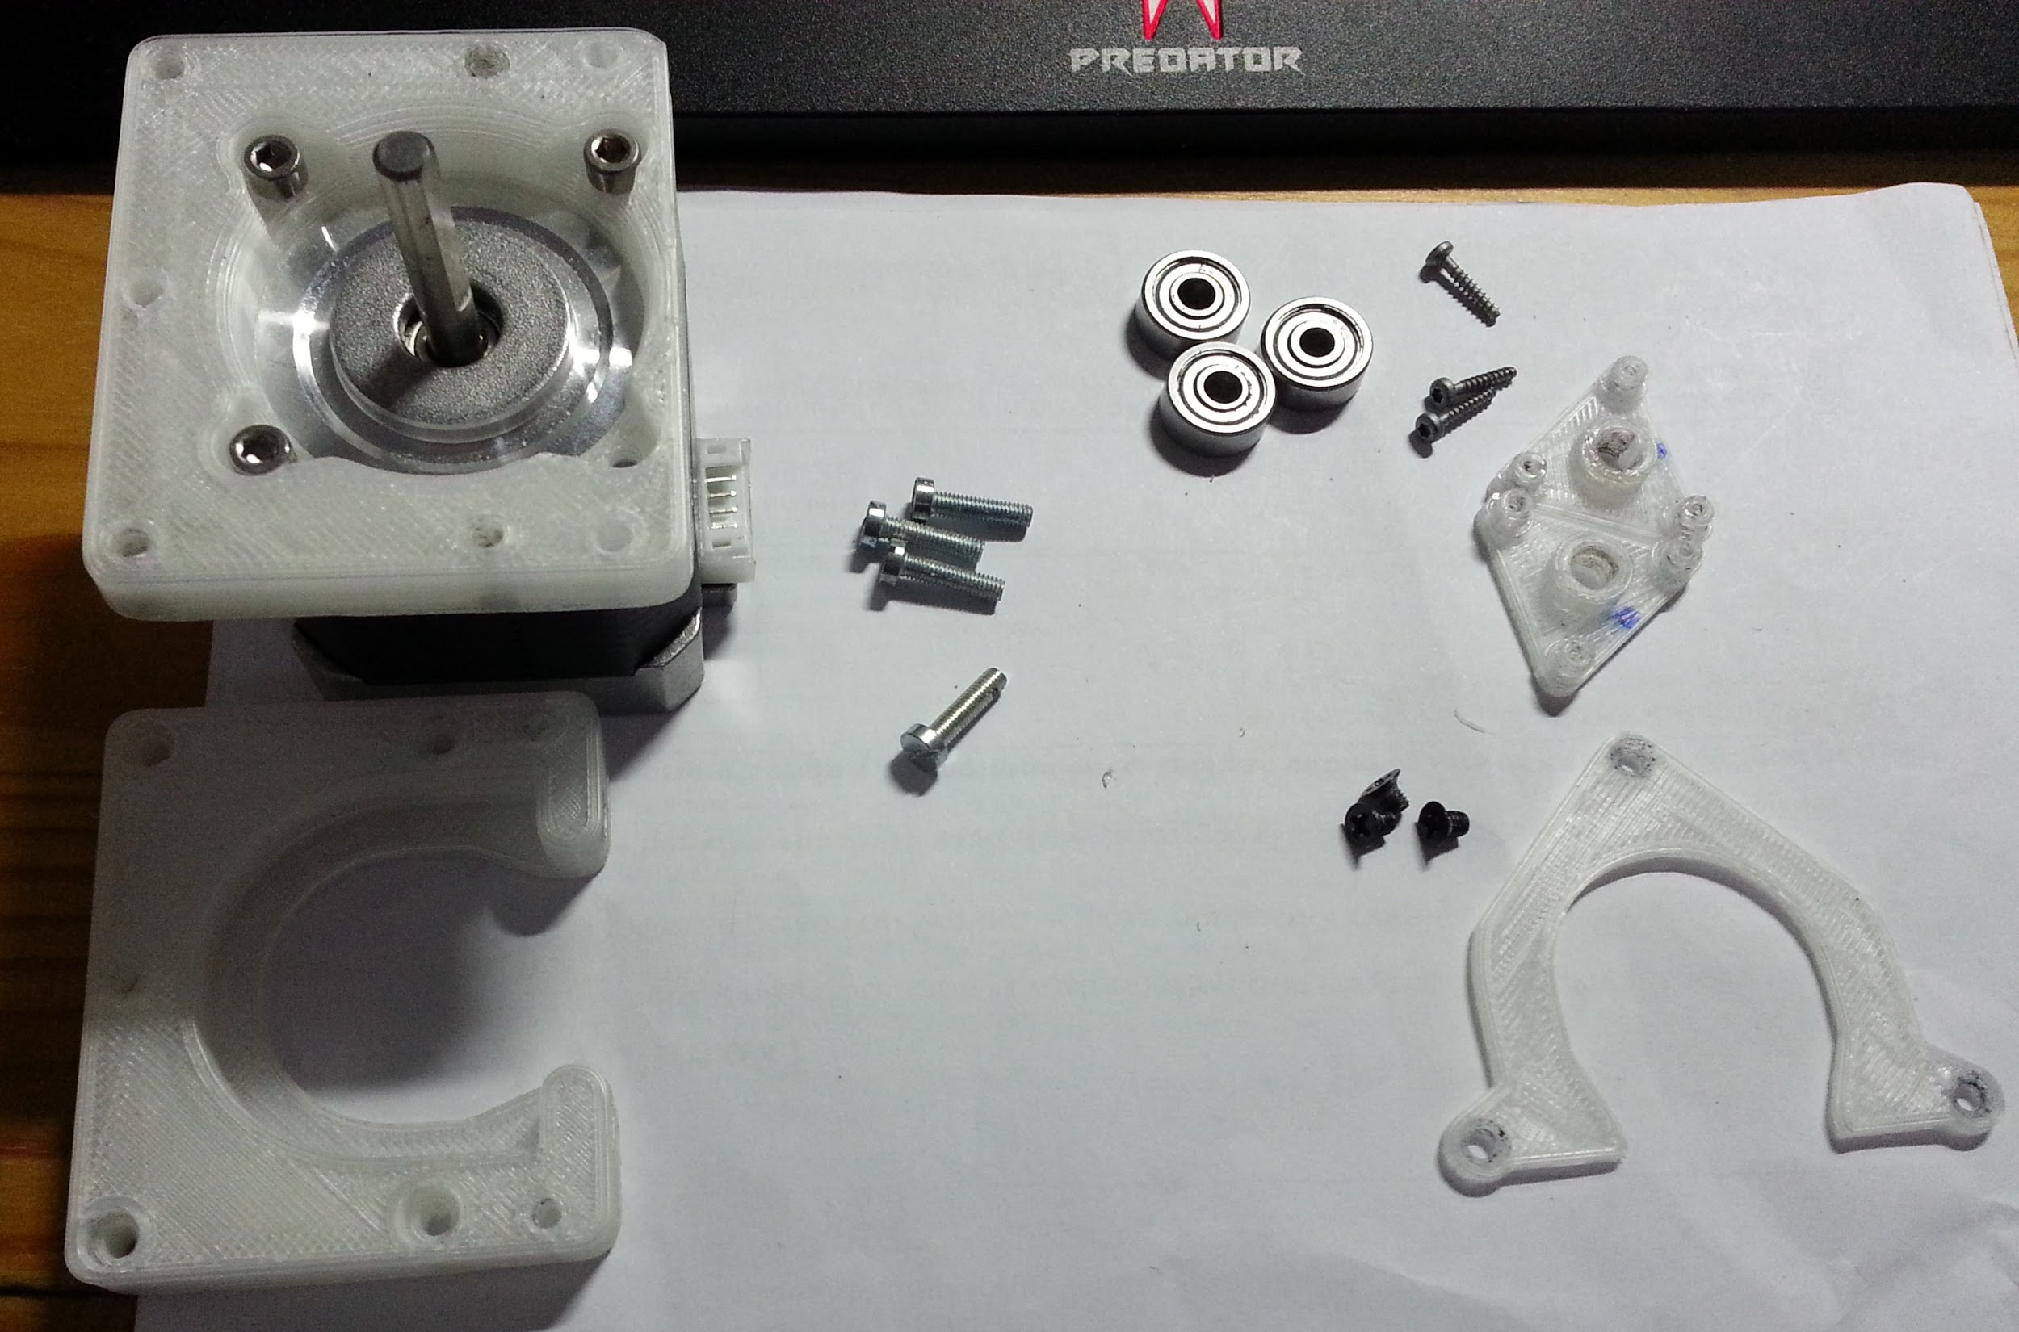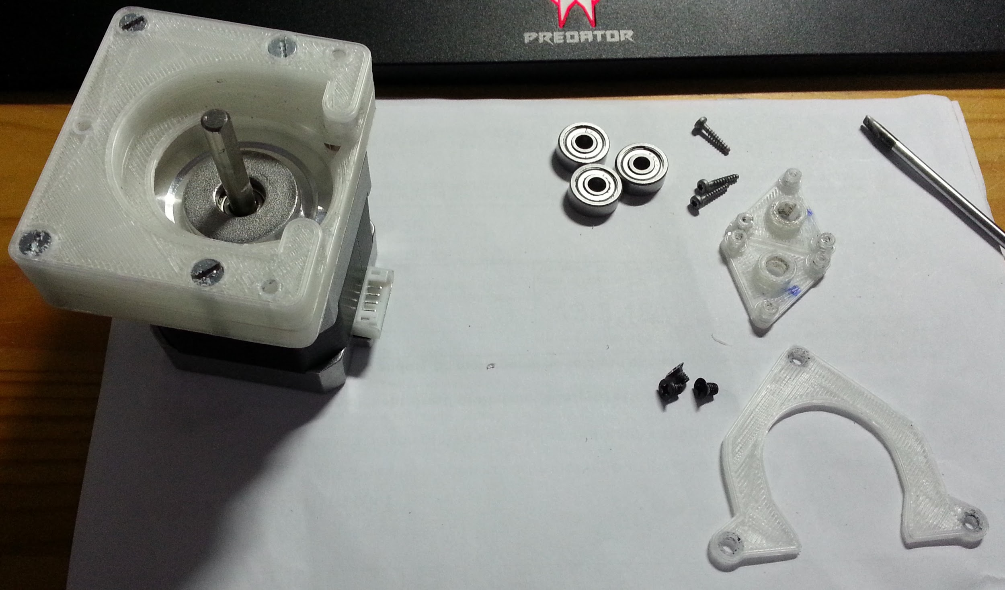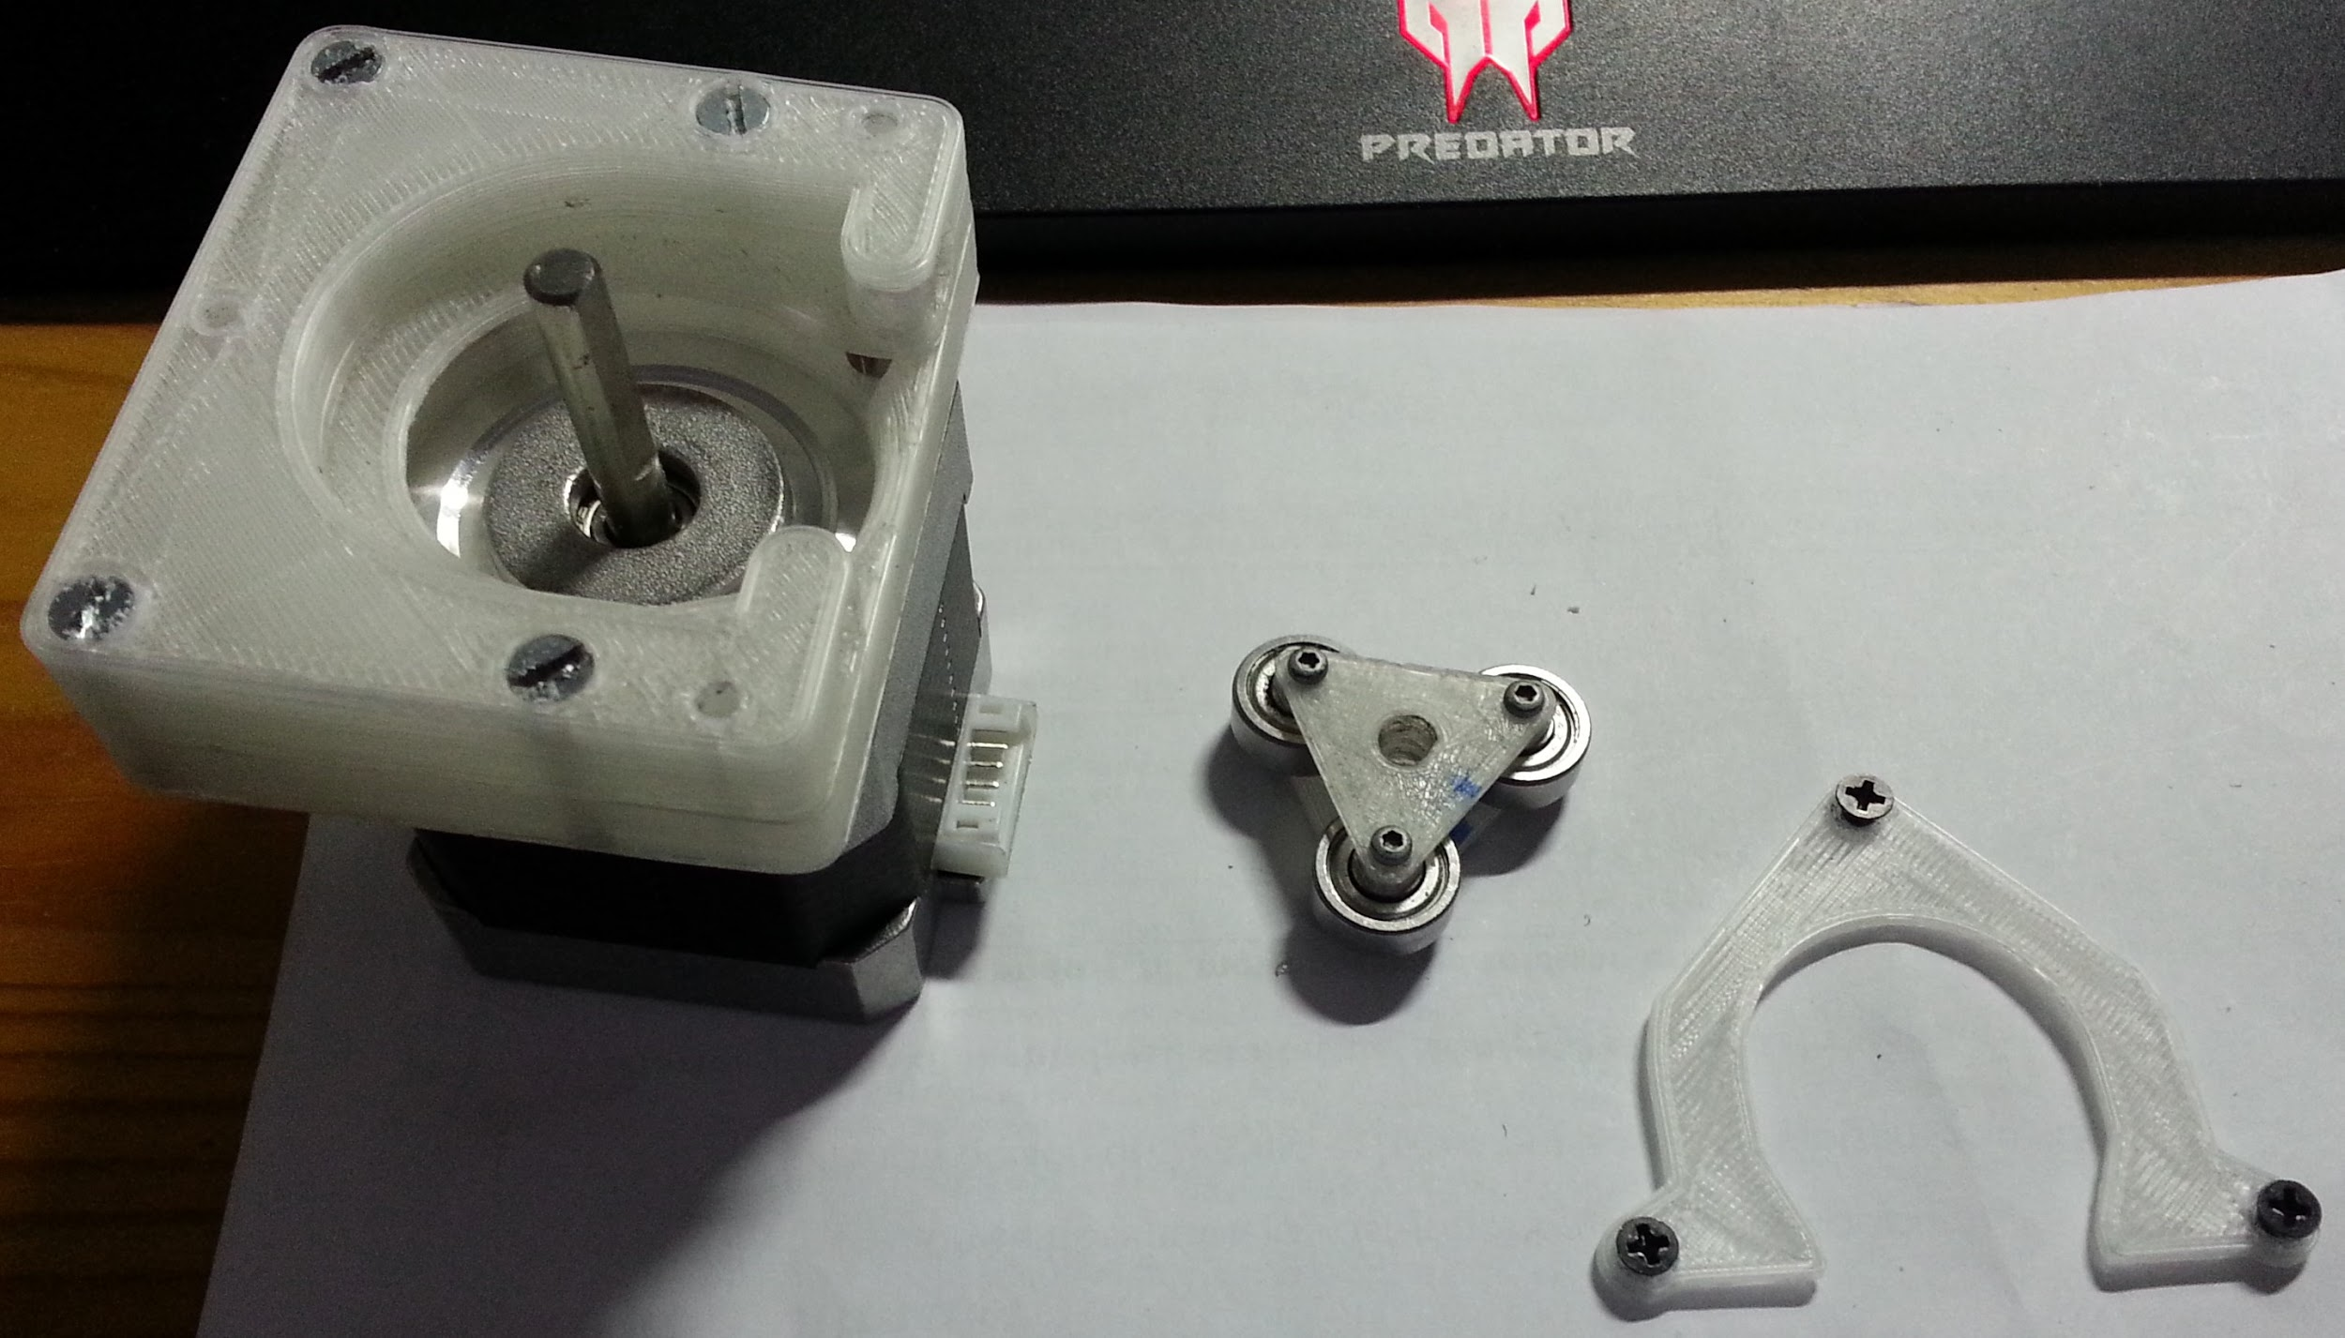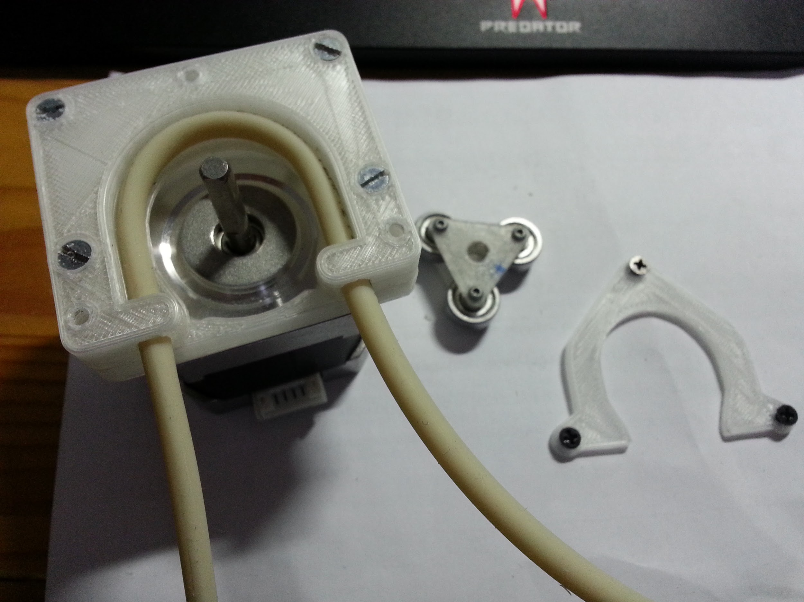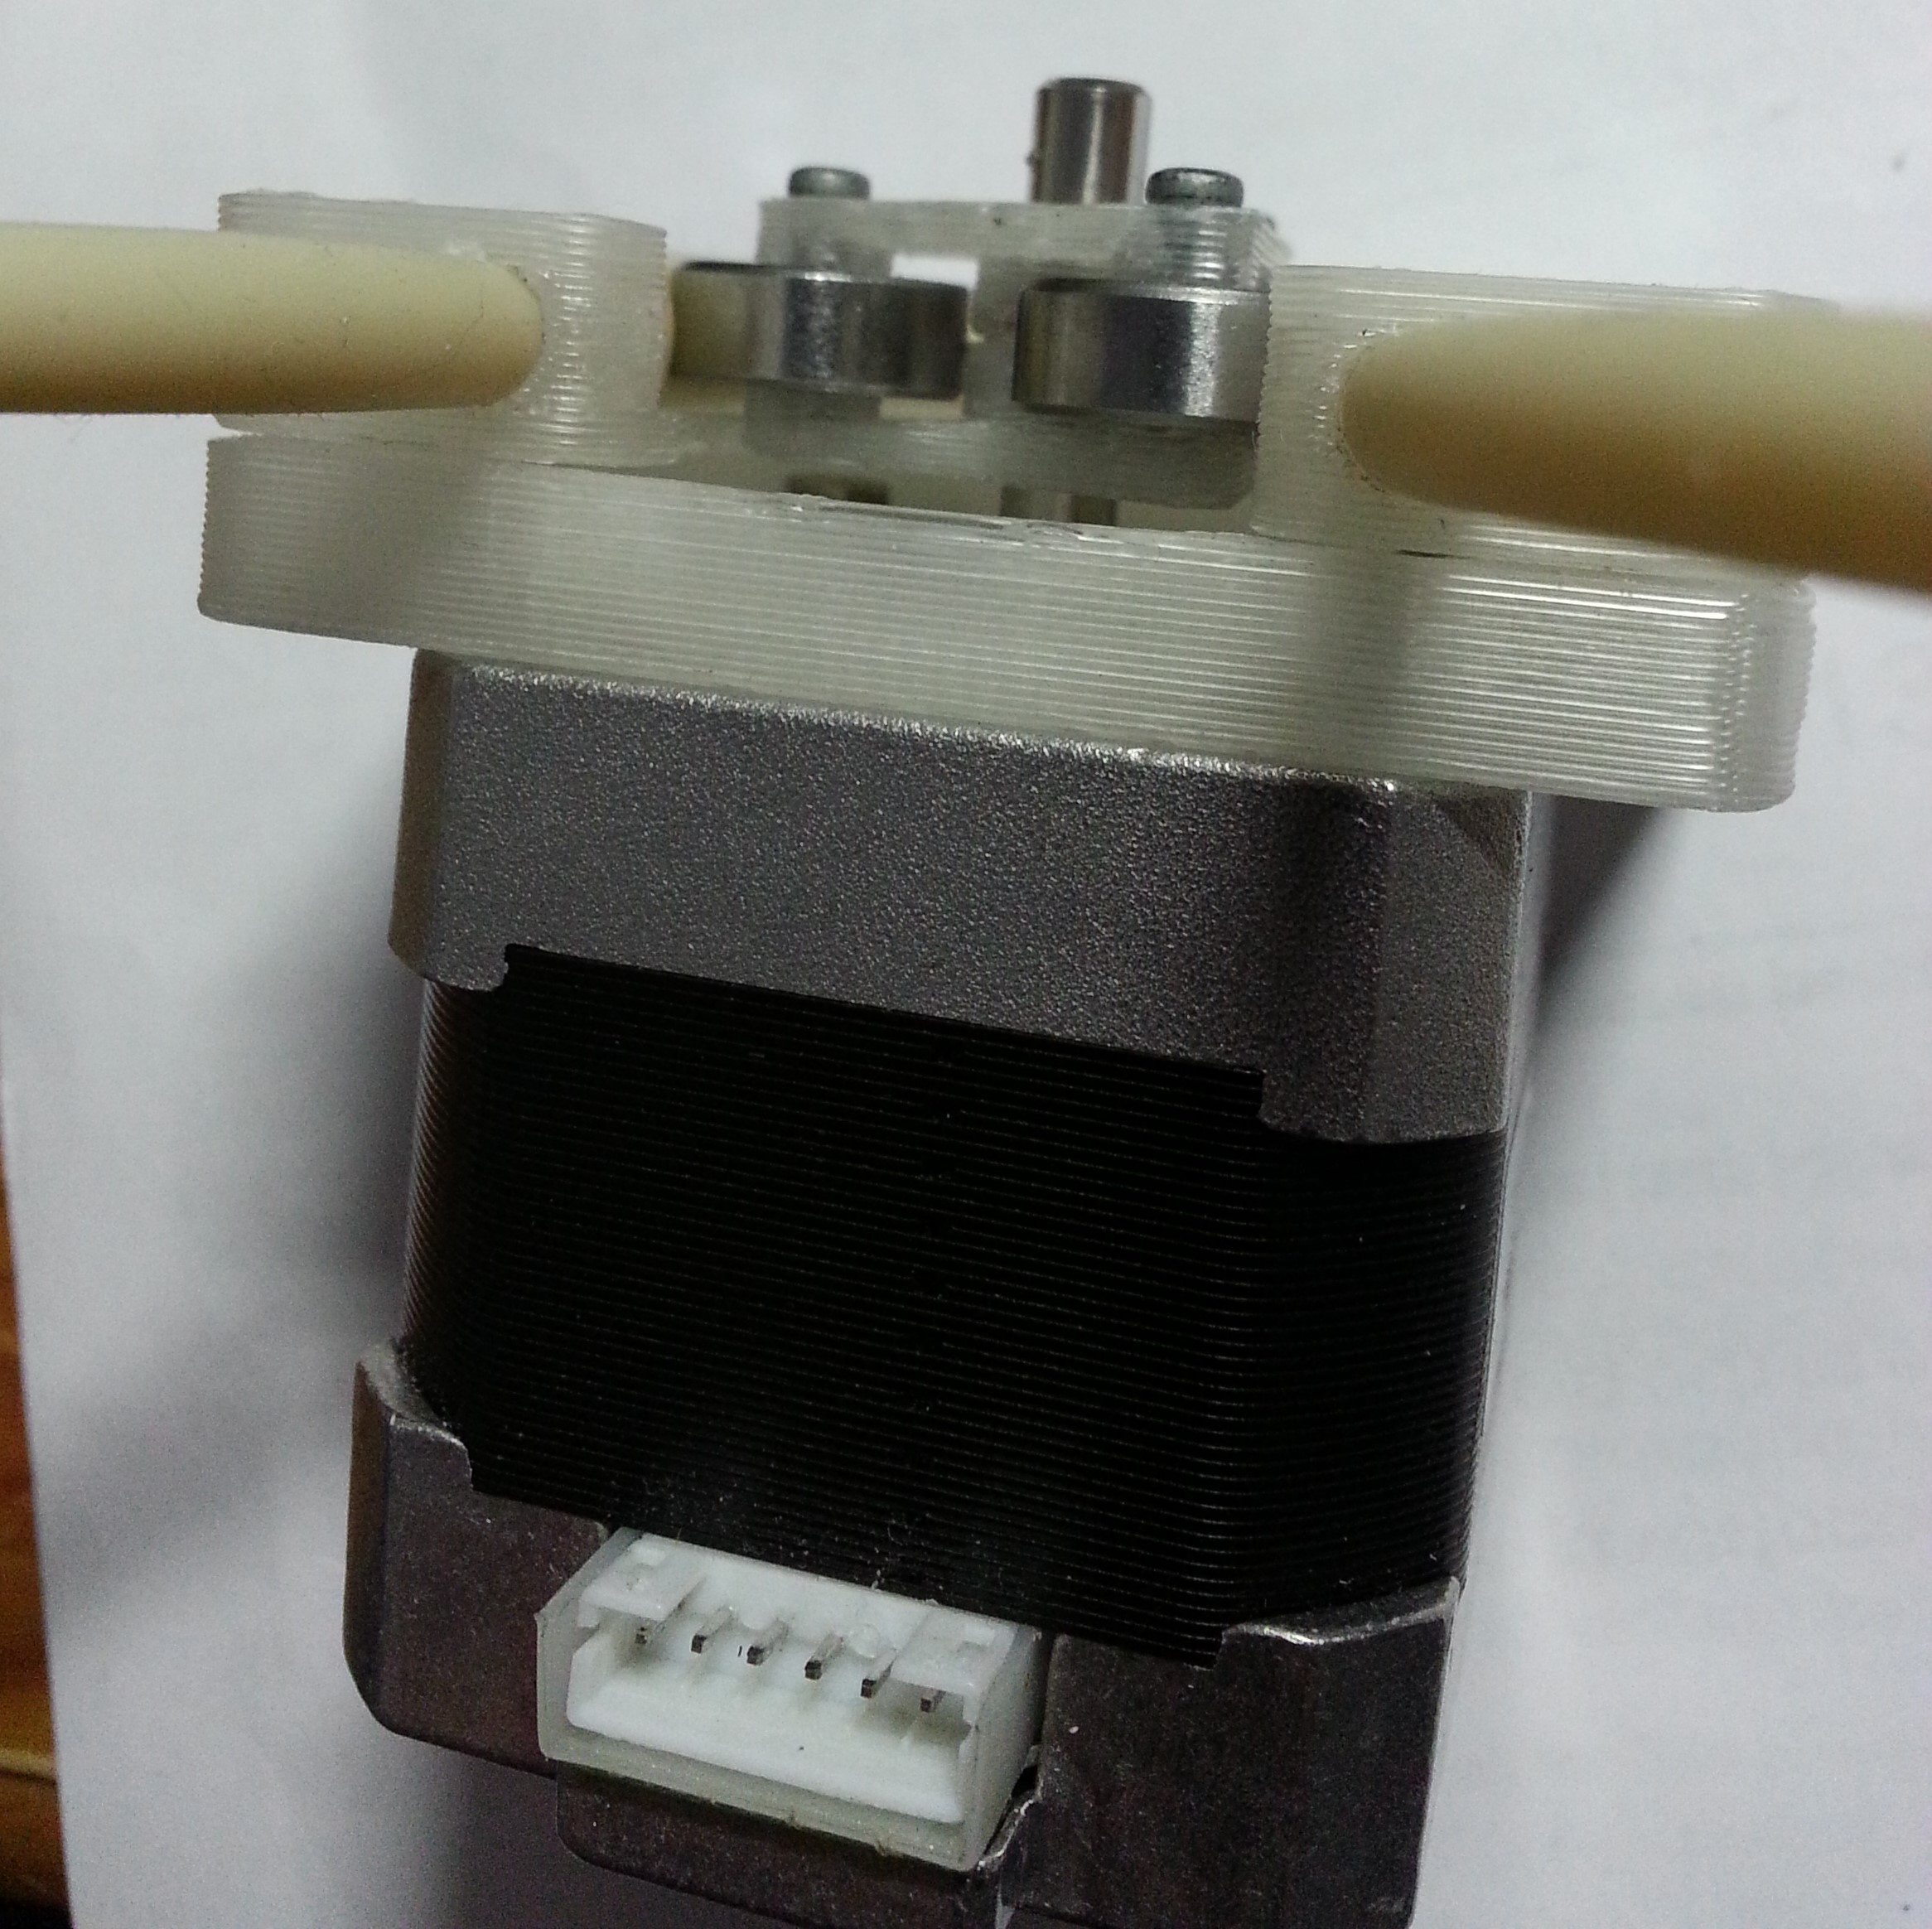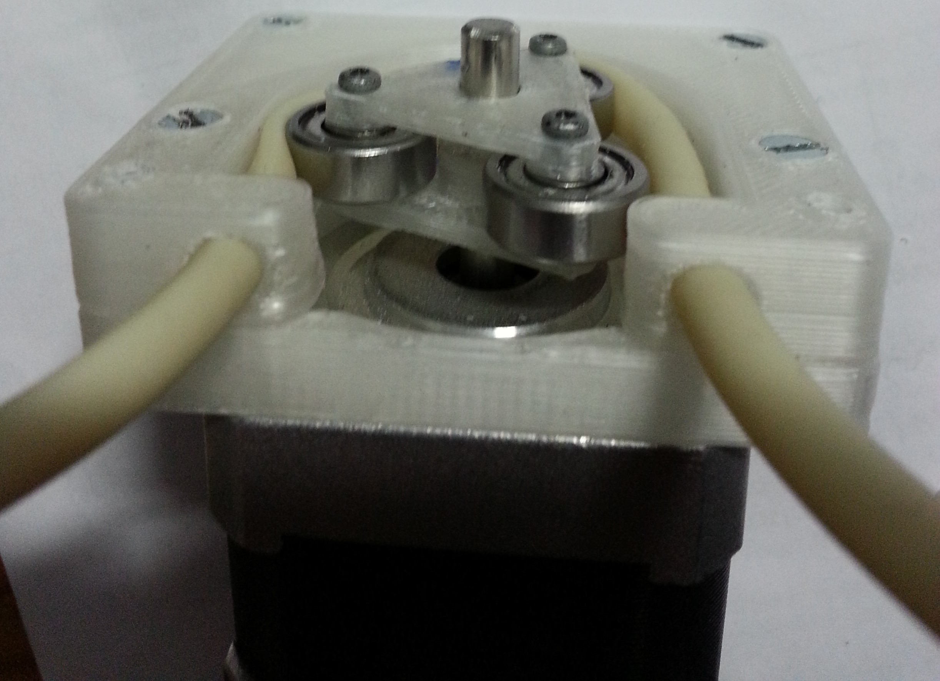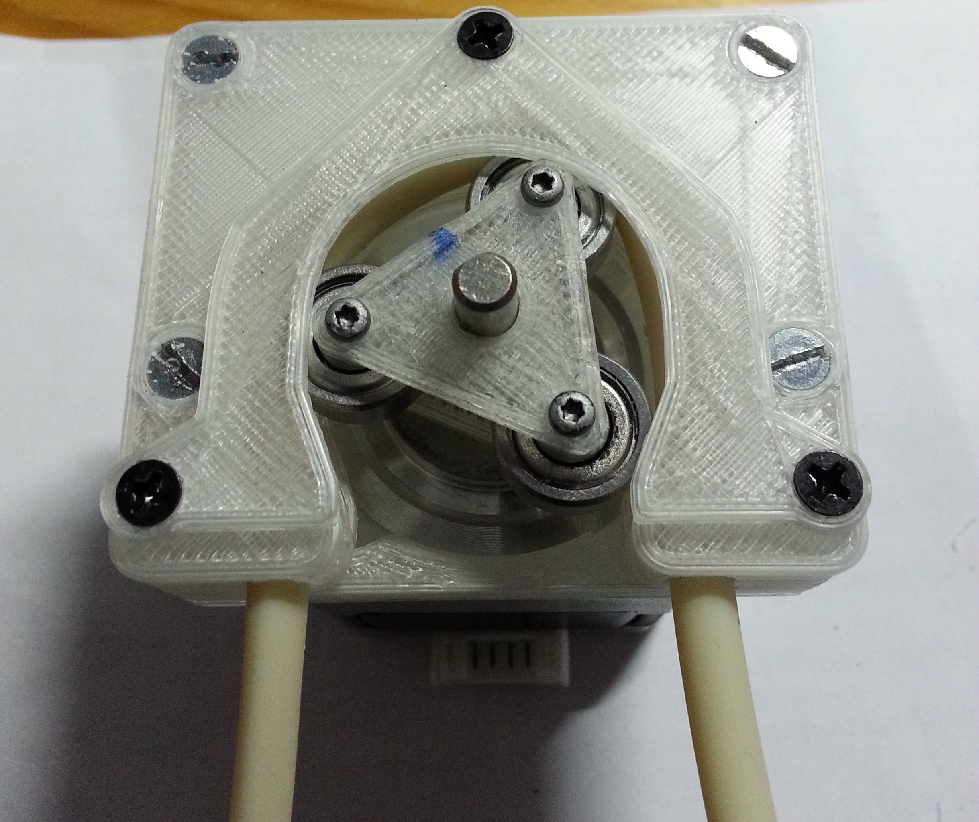

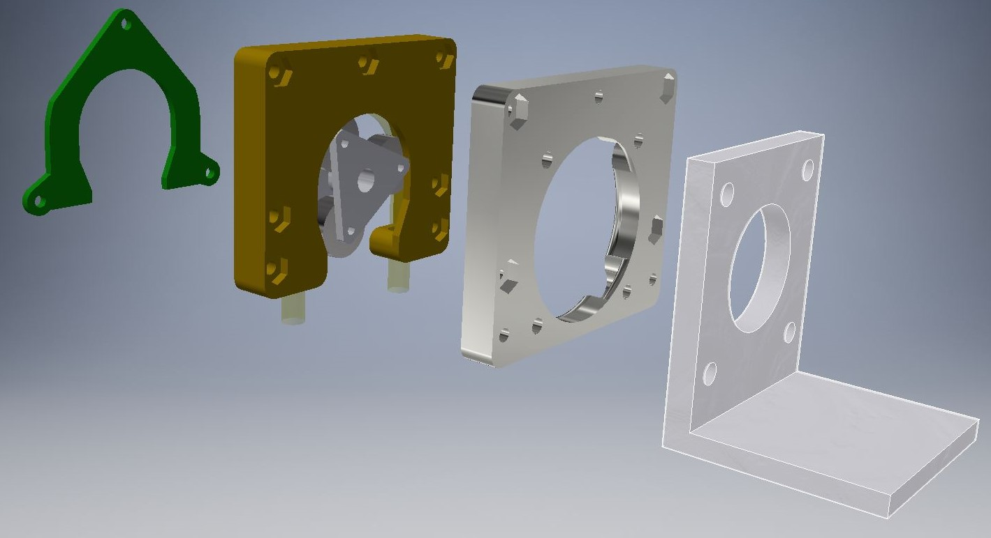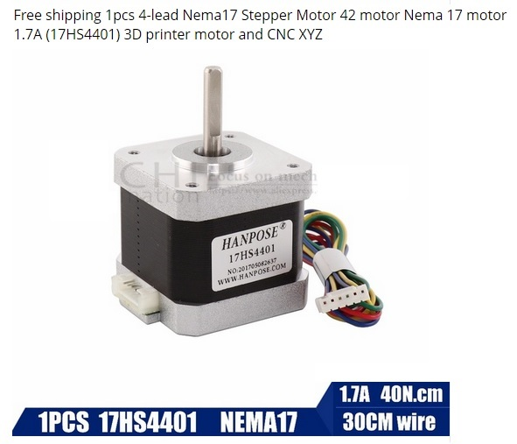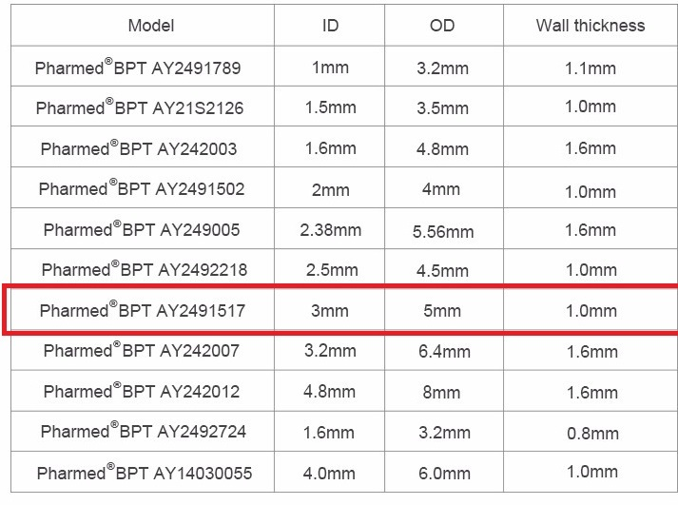

Note
I made holes for the M3 nut that are not used all of them, but they can be useful if you need to lock the parts very well to each other. I made also deep holes for the M3 screws, so if you want to use a longer screws, they have places already.
There is an attached file for the rollers if you decide to print them instead of the bearings, make sure you make their edges smooth, so you will not cut the tubing.
Also the triangles that holds the bearings, are marked by a line as in the pictures, that sides must be in the same vertical line, that sides are locking the triangles to the motor’s shaft to prevent the triangle from slipping when the shaft is turning.

I corrected the M3 nut holes size after printing this parts, so if anyone notice something that needs to be changed, please let me know.

Parts needed for the control box
Please read the whole article before you order any part. I added suggestions on how you can do it different ways, so you can choose after that the parts you will need to buy.

1 * ABS Electrical box 240x160x90mm
1 * cable gland PG 7
1 * 4Pin Gx12 Male & Female Aviation Connector Plug
X * M3 metallic screw(a nylon screw is safer for the circuit board!)
X * M3 metallic spacer (a nylon spacer is safer for the circuit boards!)
1 * Dual male 40 pin header 2.54 pitch
1 * IEC320 C14 Inlet Power Socket Fuse Switch Connector
1 * Arduino Mega 2560 R3
1 * TFT LCD screen module Ultra HD 320X480 for MEGA 2560 R3 Board
1 * Connectors cable ATA and IDE interface(from an old computer, make sure it looks like the picture below, no hole closed!)
5 * Male-female Dupont Cable
1 * LM2596 DC-DC Adjustable buck converter Step-Down(remember to power this buck and adjust the potentiometer to get a 5V output, before you connect the Arduino!!!)
1 * PCB Printed Circuit Board 5x7cm
5 * Tactile Switches (I use 2 pin tactile switch from an old printer, if you want to use a 4 pin switch, before you solder the wires on it, check the continuity with a multimeter, so that the pins are not connected when the switch is not pressed, one of them will be ground and one to the Arduino inputs)
1 * 12-24V power supply(the stepper works well with a 12V it will work also with 24V, the buck will provide in both cases a 5V to the Arduino, choose a power supply yourself, more info below)

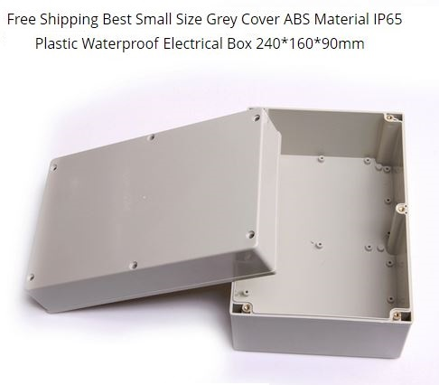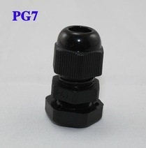
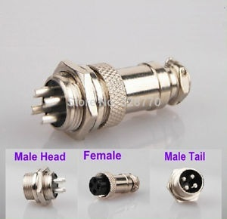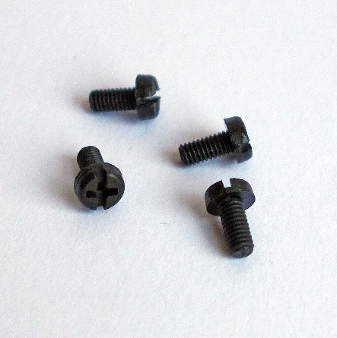
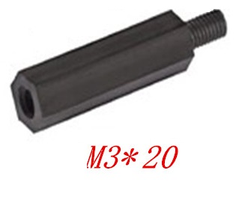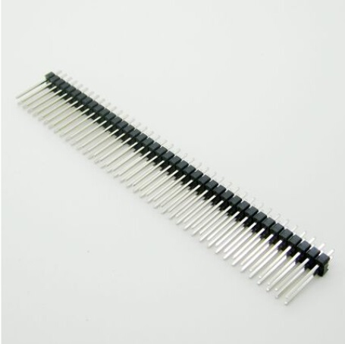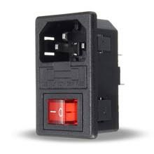
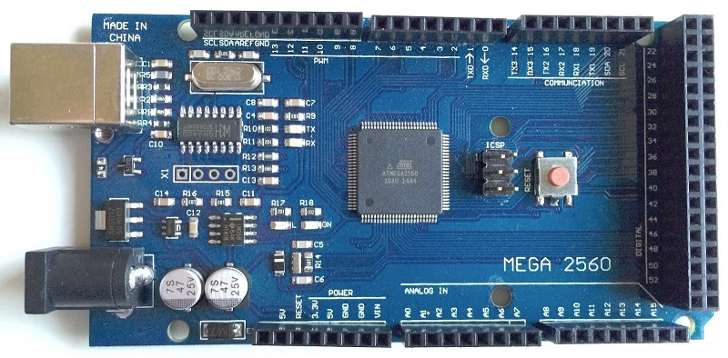
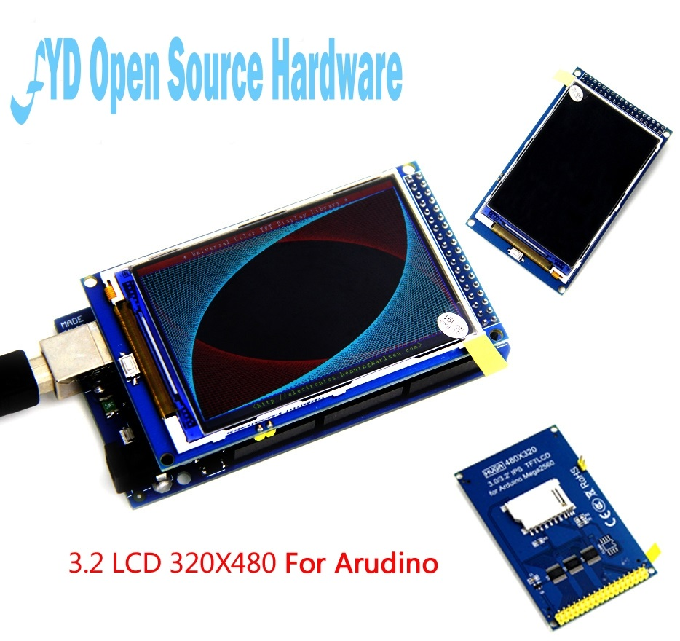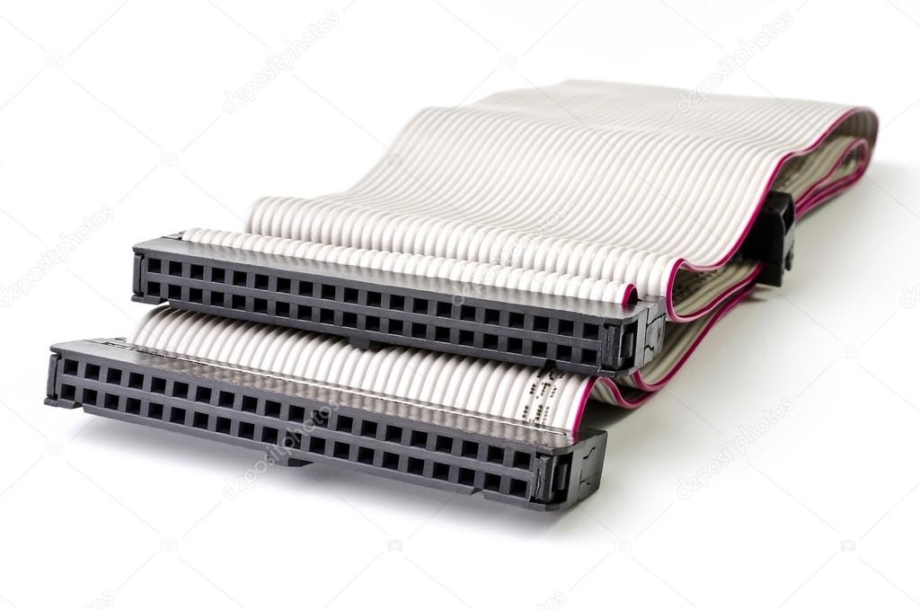
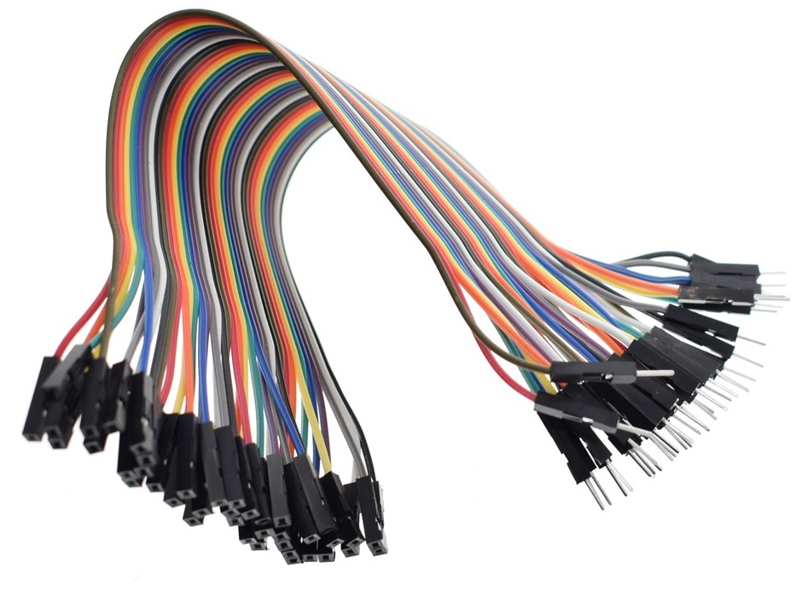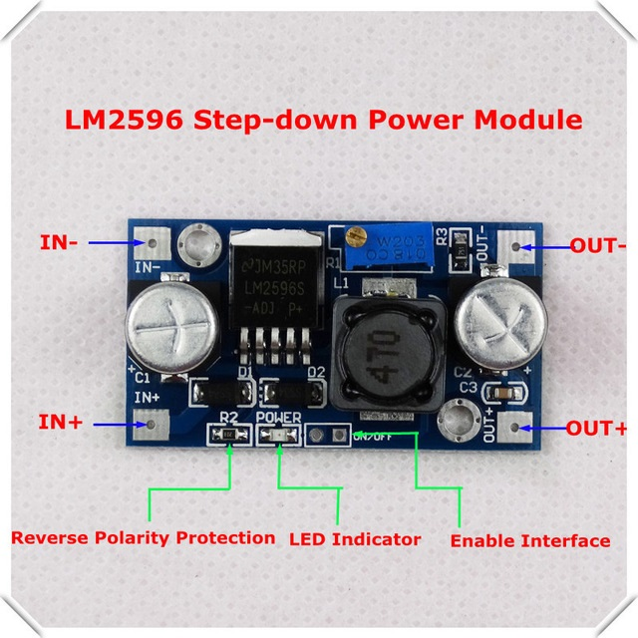
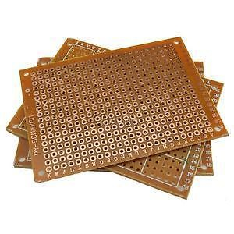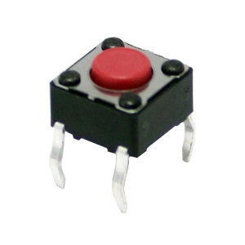

Preparing the Box

Below are pictures on how I cut the box, and steps on how I mount it.

I draw a rectangle on the box cover and used a dremel to follow the drawing, but I found it tricky to cut the box, the ABS started to melt when I cut it. I ended up by a curved lines after sanding the melted rectangle’s edges, and a rectangle bigger than the display.
I suggest that you draw the needed rectangle size, and another smaller rectangle inside it, a 0.5mm smaller from each side is enough, so you cut a little bit smaller than needed, and after sanding you can get the right size, or just google some tips on how to cut successfully the 4mm thick ABS.
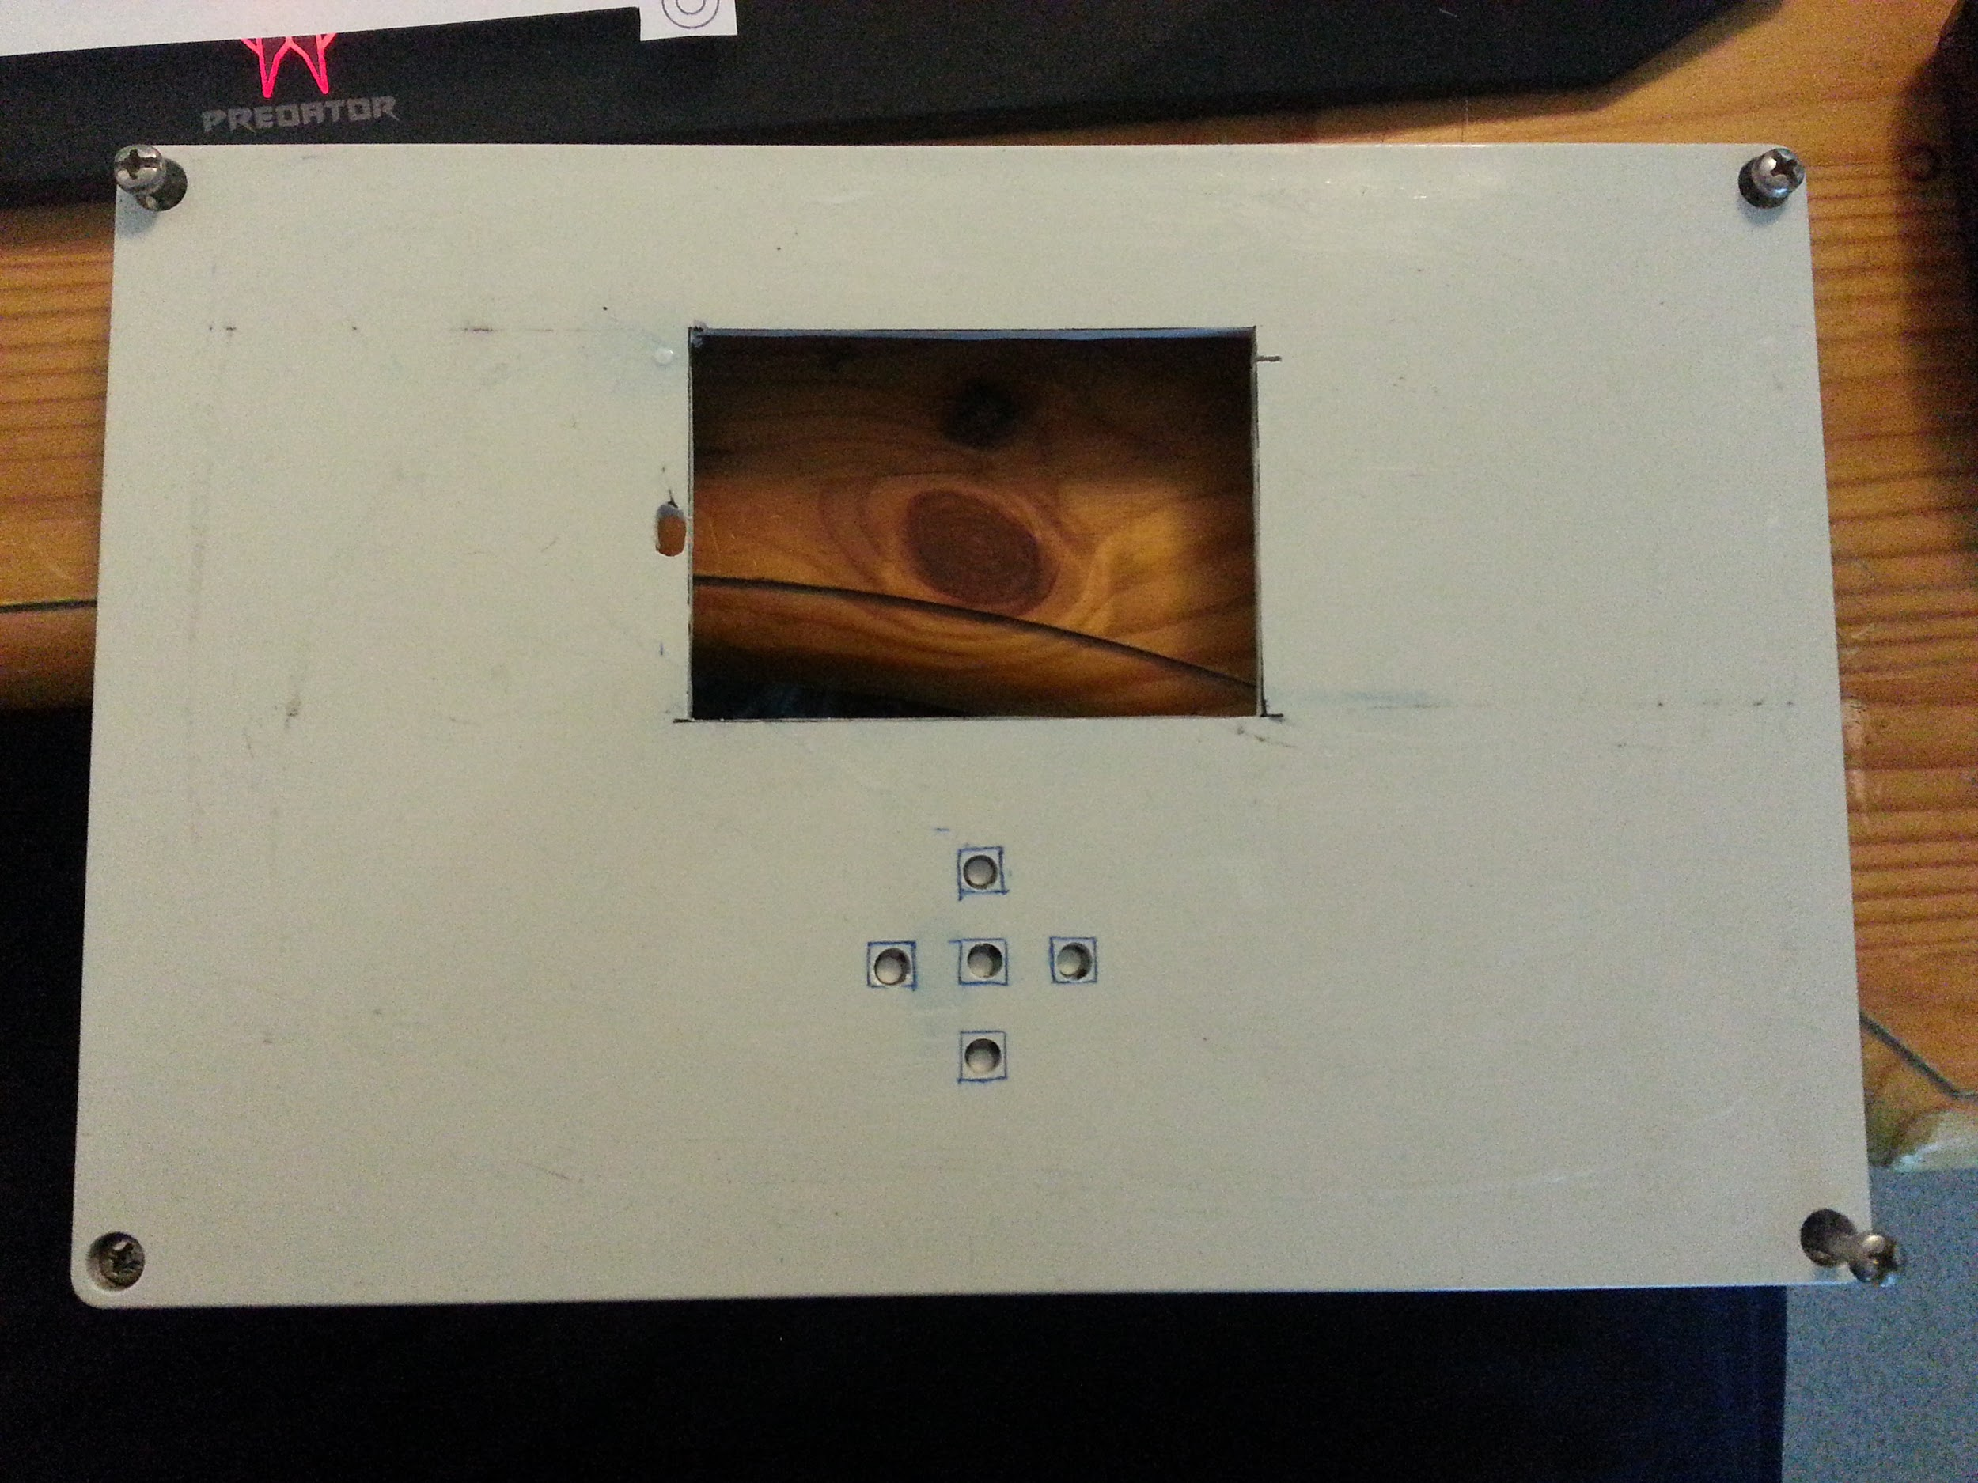

So I 3D printed a custom frame as you can see in the picture, the frame was also a good idea, it holds the display well and gets inserted tight to the rectangle hole. The STL file is provided in case someone need it.

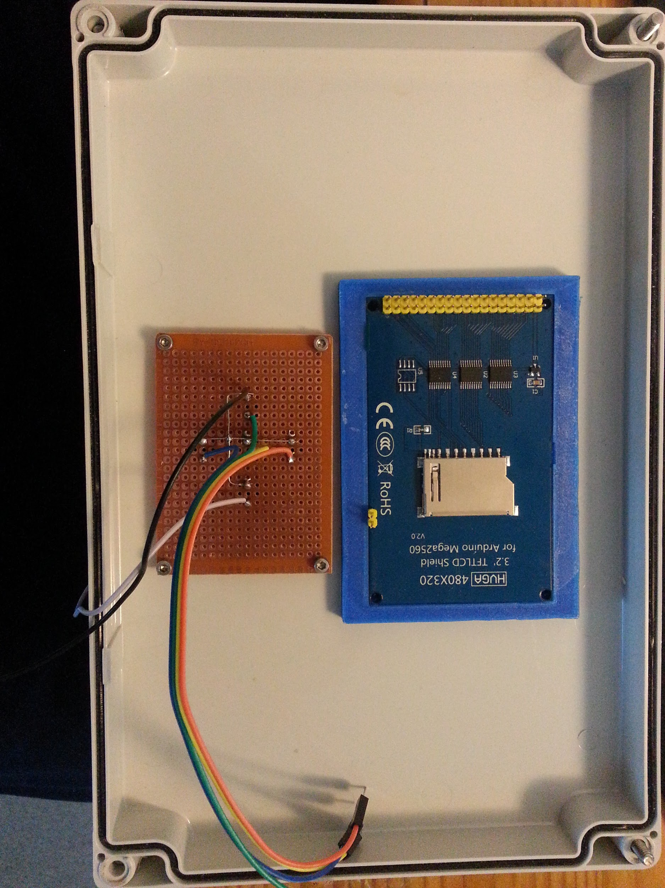

For the tactile switches, I suggest that you solder them to the PCB first as shown, then using a marker to paint the stem, take a paper and press all switches against the paper on a flat surface, you will get the exact position of all of them, then put the paper on the inner side of the cover and mark where the switches holes will be.
Make sure that between the PCB and the display you leave a space as in the picture.
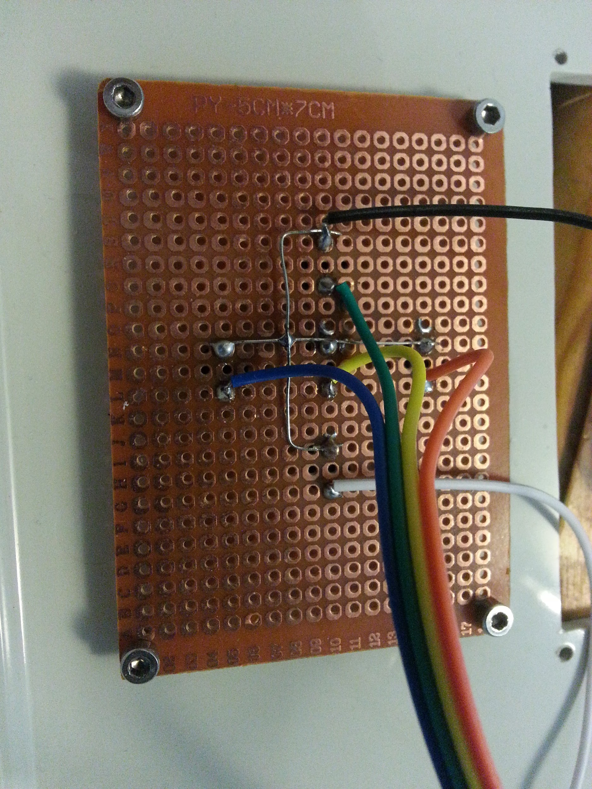
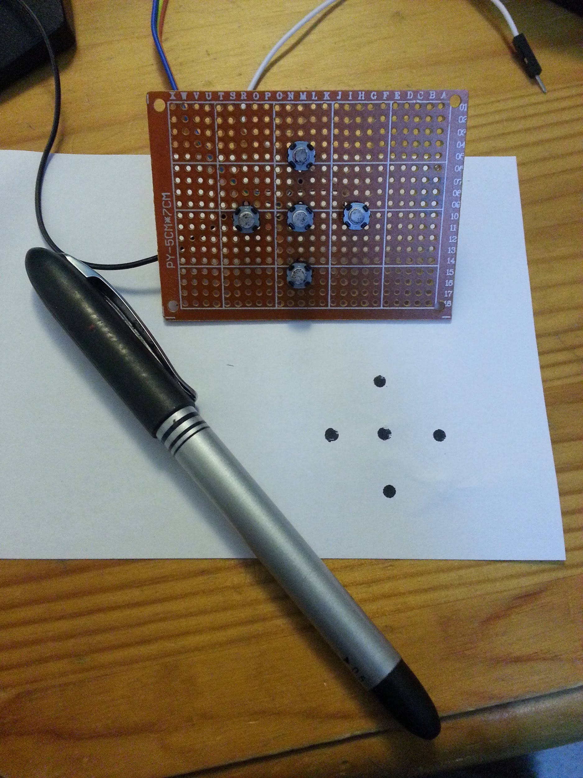

For the screw holes, using a 2mm diameter bit, I made a 2mm deep holes(you can drill through, or use a stopper to get the 2mm deep), after that forcing the 2.5mm screws to the holes to make the thread.
For the drill, for fun but useful, I made a 3D printed hand drill tool for drill bit with hex shank that you can find here:
https://www.thingiverse.com/thing:2863588
The drill can be customized easily using Tinkercad, here is the link if you want to customize yours:
https://www.tinkercad.com/things/l9BJLK66X0L-hand-drill-for-drill-bit-with-hex-shankv2#/

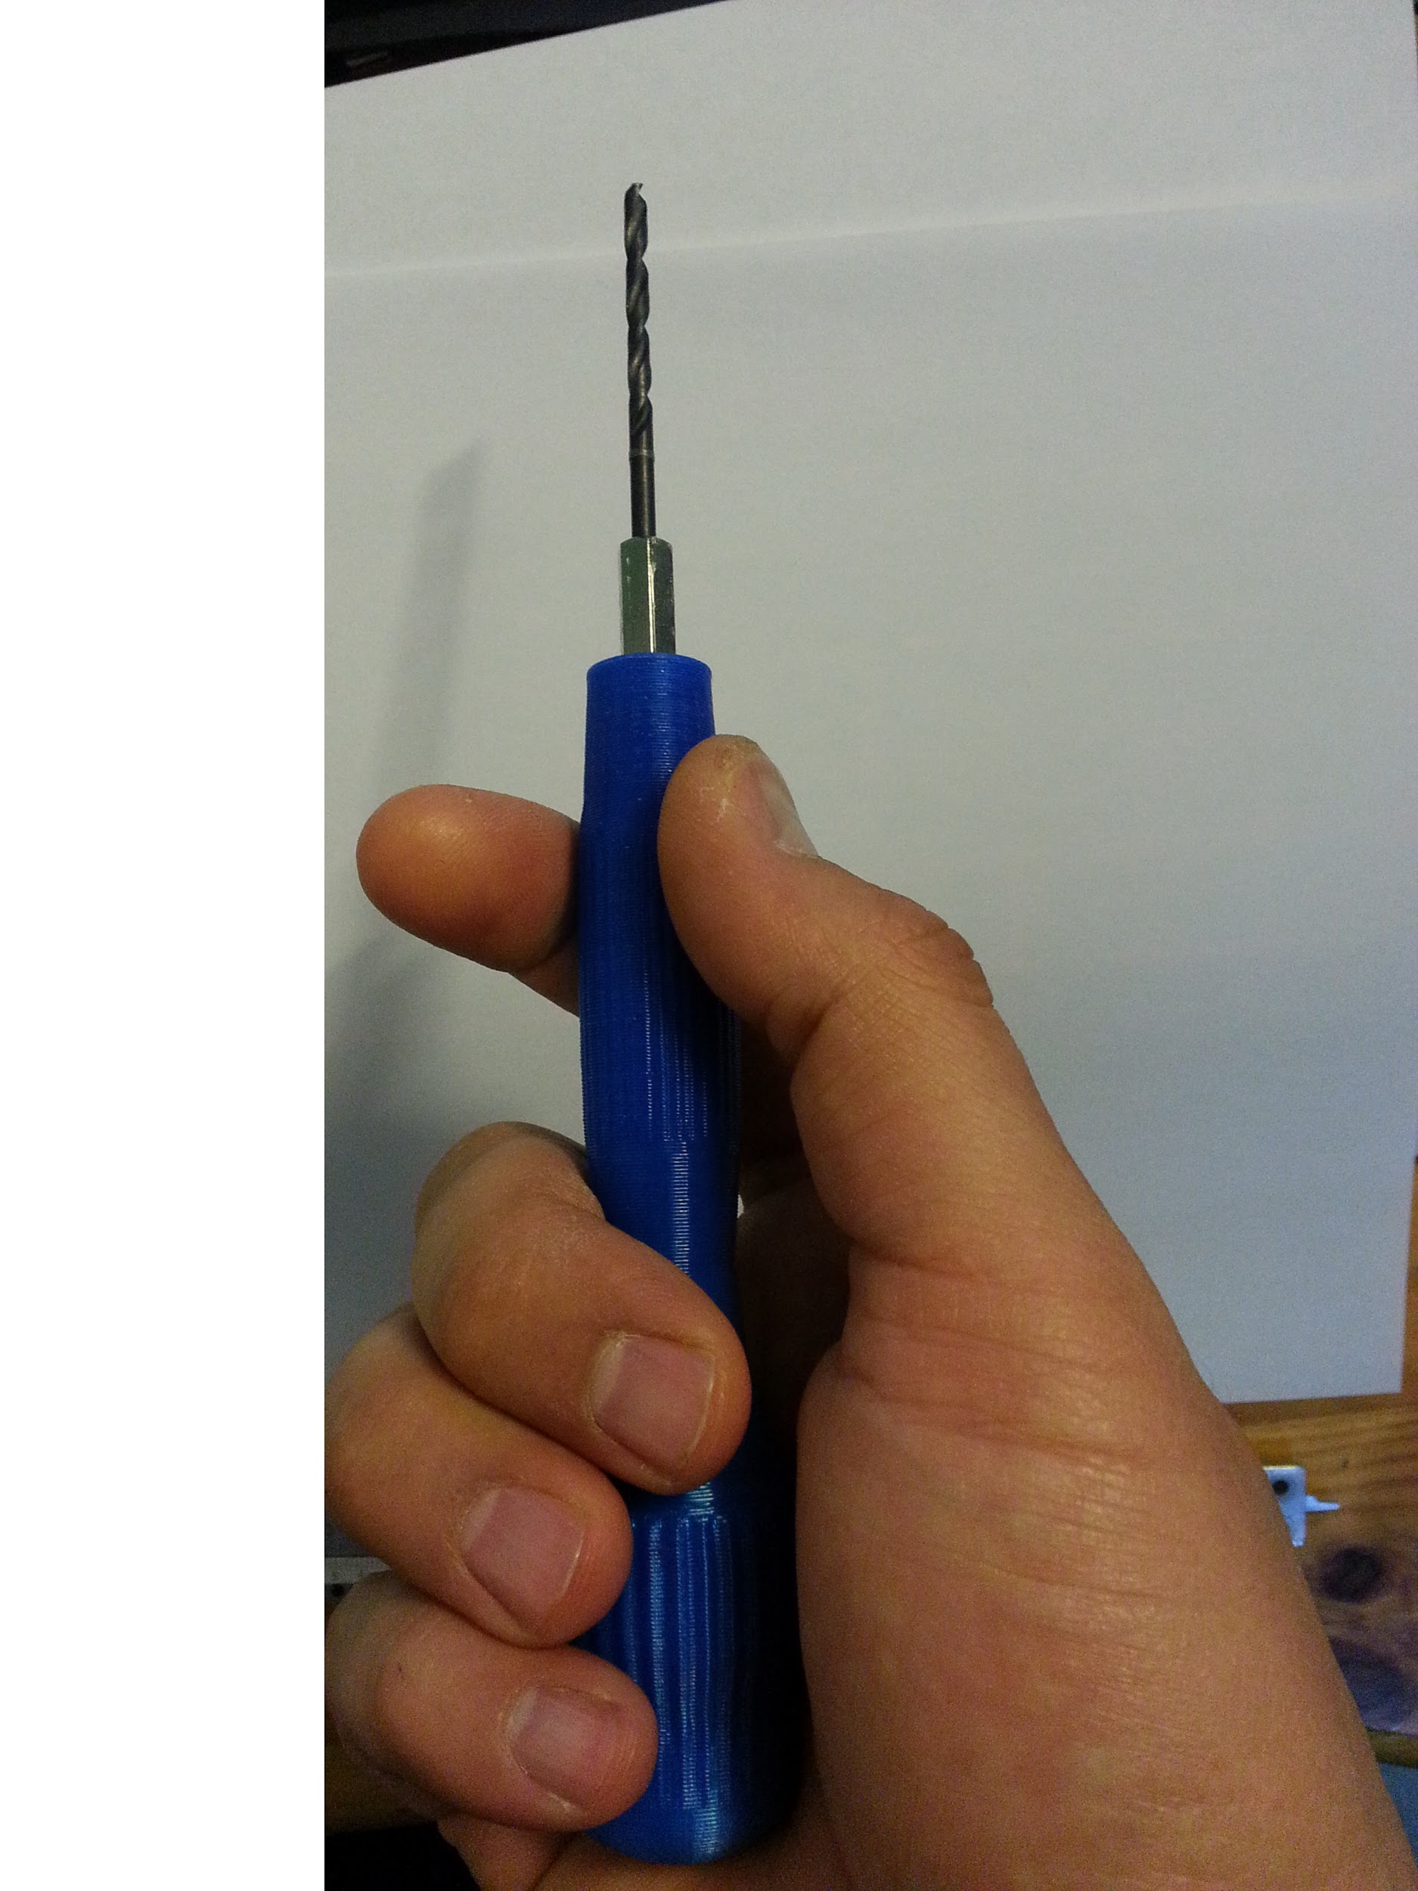

What is missing?
Here is a list of some features I need to look at, I put them as a low priority, but when I finish the project they will be done also.
- The pump doesn’t check if it can pump the given quantity in the given interval, so if you just give any value without calculation, you will get a wrong quantity, example:
- the pump can pump 200 ml/min
- but you set the fixed quantity program to:
  - quantity: 200ml
  - interval: 10 sec
  - repeat: 10 times

- here it will pump 10 sec but 200ml will not be reached, again other 10sec without reaching the 200ml repeating this 10 times and it will stop, so don’t get surprised with the final result!

- The pumped value is displayed when the pump finishes 1 cycle, example:
- 10ml each 10sec
- it will display 10, 20, 30ml each time a 10ml is pumped and not updating 1,2,3..10

Why this project is not complete?
The functions I needed to do with this pump are reached, and the pump is currently in use, but because of shortage of time and the plans I was thinking about in the beginning on how to do this pump, prevented me to make it complete.
I spent hours to design a 3D box to house the modules(Arduino, display..) and a housing for the stepper, I wanted to order the boxes from: www.chinaenclosure.com
but I didn’t know that they need to start a project for each box, and the cost to make a molding for mine was 13000$ so you know… I forgot that way and started other way.

Why the stepper is separate from other components?
Because I needed the pump to drop a defined quantity of liquid to a tank, and near the tank is always wet, so it is not safe to put the electronics there nor I wanted to make 3 meters of the tubing. So I decided to make the stepper separate with a long wire.

The goal from sharing the project even it is not complete
I shared this project, because I don’t want to keep the information until the project is complete to share it, and not all people need the box as mine, or the final design, but the code and the schematics are enough for many to start this project, some will make it quickly and even better than mine,

The idea here is to make a, let’s call it OSP2 (Open Source Peristaltic Pump as the title), available and keep providing updates, and maybe getting help from people with different skills and experiences.

As professional pumps are very expensive, I wanted to share this project to allow people with a small budget but in need for a precision dosing pump for their research, watering plants, aquariums, hobby or any other liquid pumping applications.

So comment, share, suggest optimisations, try it and let us all know what do you think ;)

More info

Visit my pages for updates and more informations (simple schematics on how to drive the stepper if you don’t want to use the Arduino are provided here):

http://karim.lakras.eu/index.php?page=hobbies&lang=en&cat_hob=peristaltic

Videos
https://youtu.be/k6mOiT1_ZLY
https://youtu.be/oCNA98Bd8yQ

Names & references

I found many useful posts and informations about the arduino, but the listed below are what I kept as the most useful that getting me quickly started with the arduino and with this project:
https://howtomechatronics.com/tutorials/arduino/lcd-tutorial/
http://www.rinkydinkelectronics.com/library.php Thanks to Henning Karlsen for his help with some of his libraries. I can’t get the file.create() from tinyFAT library to work(this function creates a corrupted file...), this is why I used SdFat library, it is memory consuming, but I didn’t have choices, but later I will try to debug this if possible.

